**Aim:** Create a simple cloud software application for Library book reservation system for SIMATS library using any Cloud Service Provider to demonstrate SaaS include the necessary fields such as Title of the book, author, publications, Year, edition, no of copies, Rack no, status (taken/returned) etc

**Step 1: create application ‘Library Book Reservation System’ and add ‘search books**

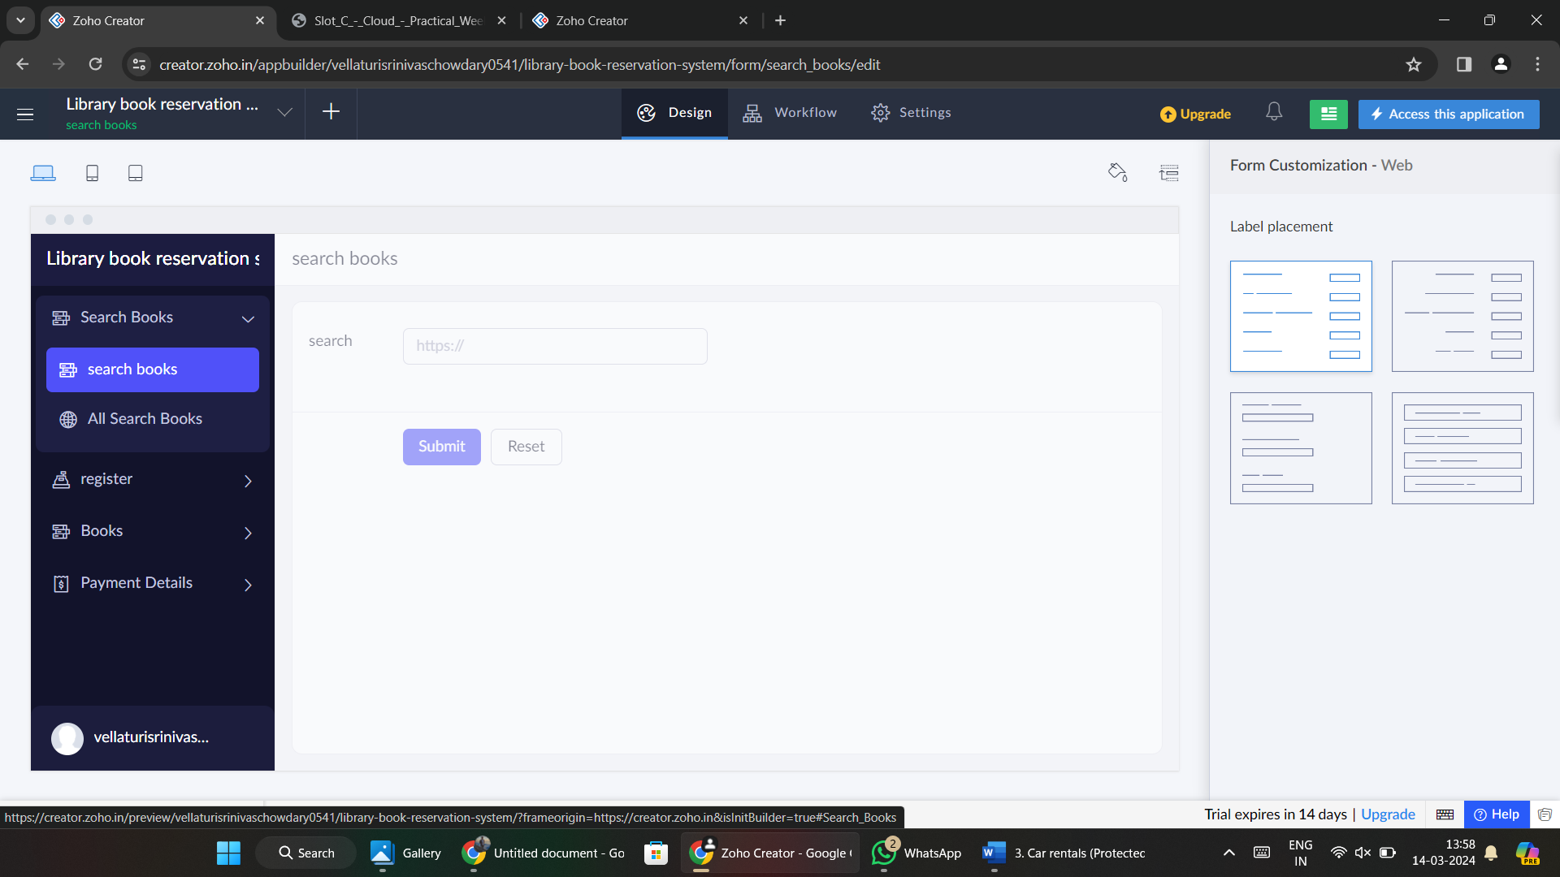

**Step 2:** Create form ‘register’ and add details.

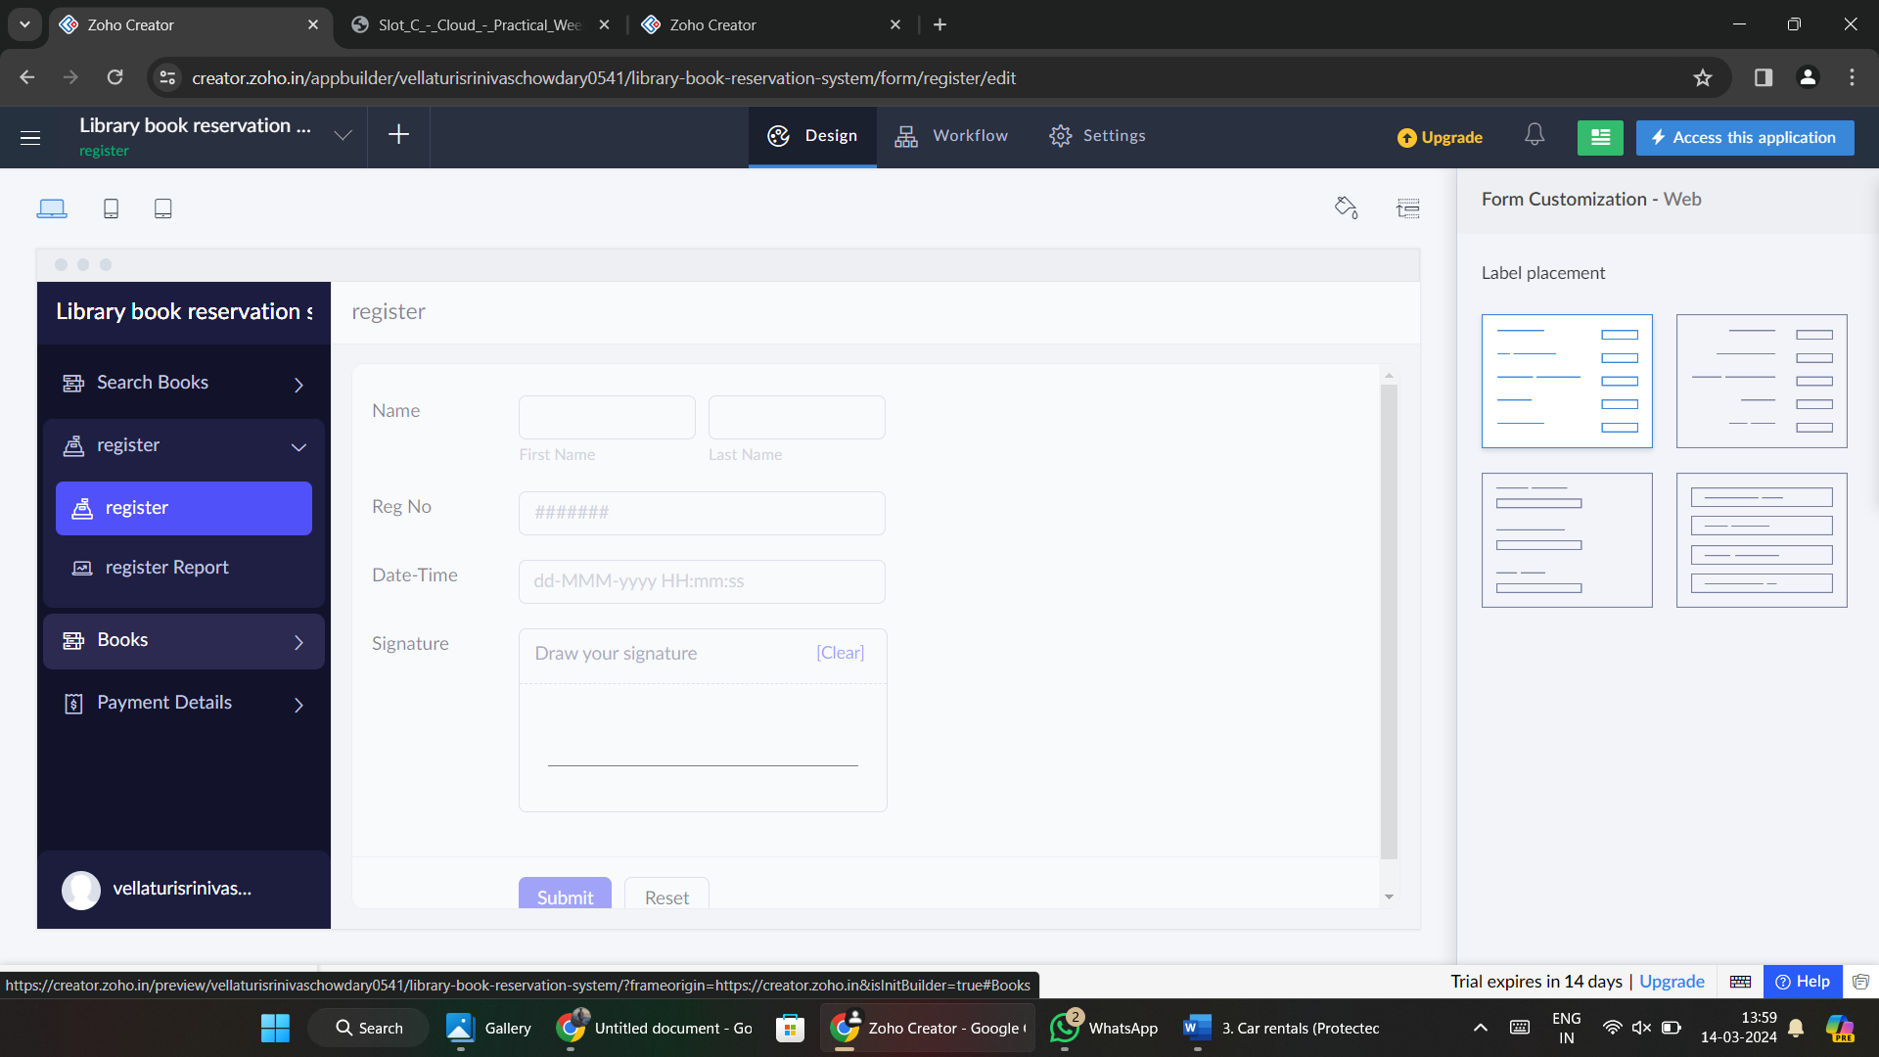

**Step 3:** Create a form ‘books’ and add details.

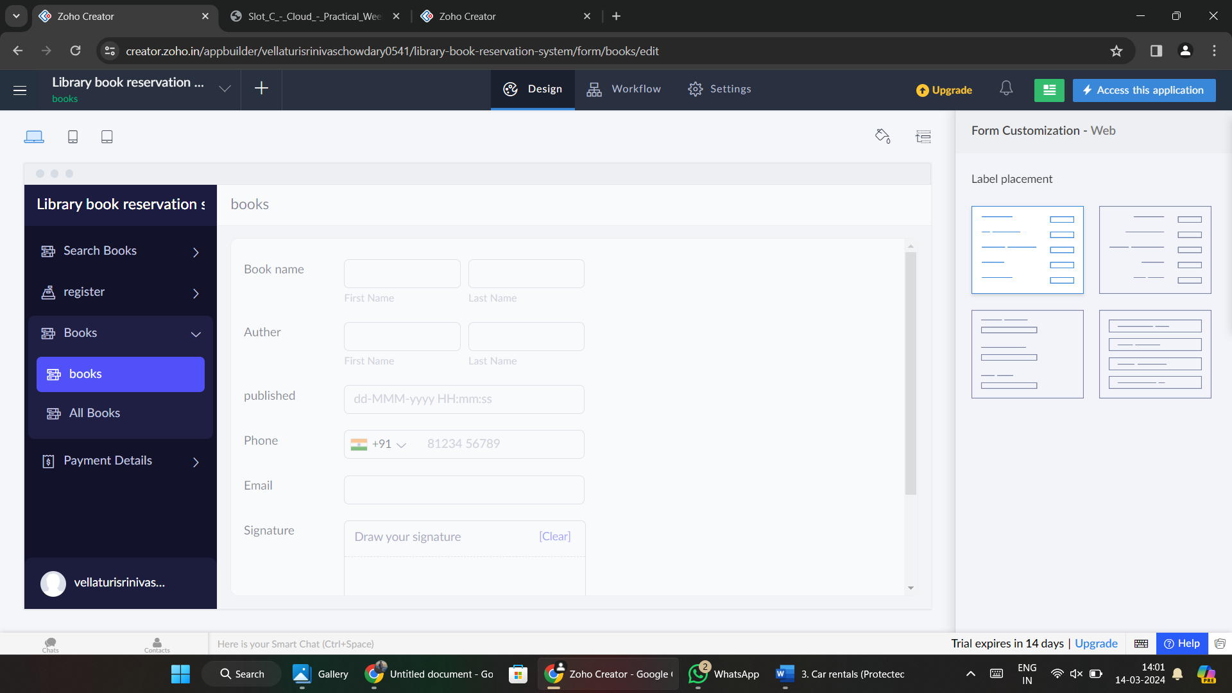

**Step 4:** Create a form ‘Payment Details’ and add details.

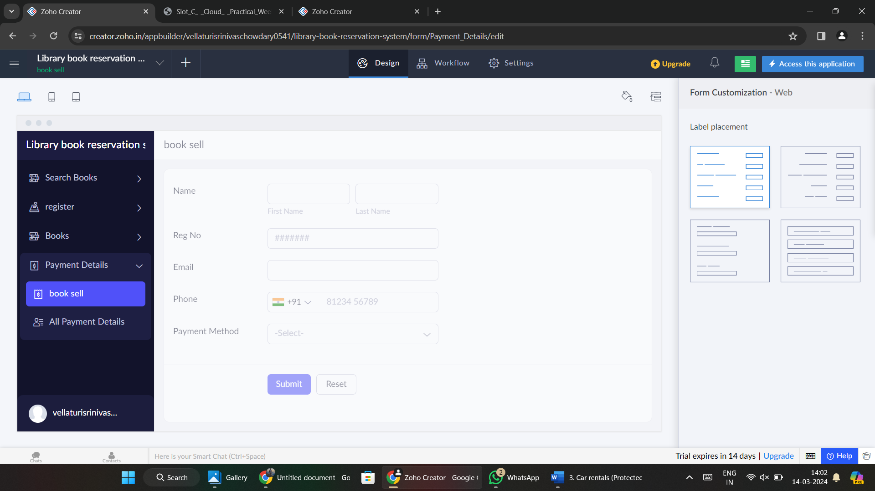

**Step 5:** Fill some details.

